Chapter 5: Efficiency
"The search for knowledge
is a long journey
towards the unknown.

As I prepared to set out,
the path lay before me,
infinite.

I hesitated.
How could I traverse a path with no end?

The sun rose behind the forest.
I stood up.

The longest path
is traveled
one step at a time."

Fabhrius.
(from the book, 'Rainland's Lost Codex')

Introduction

Not all computers are the same.
Certain details make them different from each other,
such as,
- the ability to tackle more complex problems,
- or to perform a greater number of operations per unit of time,
- or the ability to consume fewer resources
to accomplish the same task.

We will also find differences between the methods
that a computer could use
to solve the same problem.
The same problem can be approached in different ways,
using different procedures.

So, there exists a great variety,
both among computers,
and among the procedures they use to solve problems,
and they can be measured and compared.

In this chapter,
we aim to obtain a measure of the

"Algorithmic Efficiency"

of the intelligent system based on living creatures
that we have used in the experiment
conducted in Chapter 3.

How efficient is "the method" it has used to solve the problem?
Is it a good method?
Can we improve it?

We will be able to establish an approximate measure of the system's efficiency by reasoning about the facts
we have been able to observe.

And we will say that

an algorithm is
more efficient than another when
it finds the solution to the problem
with a lesser number
of operations.

Different Algorithms

An algorithm is the description of
the procedure used to solve a problem.
Or in other words, it is the sequence of operations that must be performed
to achieve the desired result.

For example, if we wanted to sort a deck of cards, how could we do it?

It's possible that
different people
may propose different ways
to achieve the same result.

And since the methods are different,
it's also possible that,
some methods
achieve the result
with less effort than others.

Given the possibility of doing the work in different ways,
we prefer the algorithm that achieves the goal in the most efficient manner.

Performing the work with a lesser number of operations translates to
a lower consumption of resources, particularly time and energy.

To see practically how we can measure and compare the efficiency of different algorithms, let's look at an example of two ways to sort a deck of cards.

How to Sort a Deck of Cards

Method 1:
I go through the entire deck, comparing card by card
in order to find the one with the lowest value.

After having gone through the entire deck,
I will have located the card with the lowest value
and I separate it from the deck,
placing it in a pile that I'll call
"sorted pile".
The rest of the deck I'll call
"unsorted pile".

Now I have the deck separated into two piles.

"The sorted pile"
which contains one card.

And "the unsorted pile"
which contains the entire deck
except for one card.

Now, I go through the unsorted pile again, from start to finish,
comparing card by card,
searching again for the one with the lowest value.
After having gone through the entire "unsorted pile"
I separate the card with the lowest value and place it in the "sorted pile".

Now, the "sorted pile" contains
two cards,

and the "unsorted pile" contains
the entire deck
except for two cards..

I go through the "unsorted pile" again, from start to finish,
to extract the third card with the lowest value.
And I repeat the same procedure over and over
until there are no more cards left in the unsorted pile.

Then, the entire deck will be in the sorted pile,
and the cards will be sorted from lowest to highest.

Method 2:

I prepare space on the table for each card in a grid.
Thus, each card from the deck has a reserved place on the table,
which is currently empty.

Once this is done,
I pick up the first card from the deck, let's say it's the five of diamonds,
and I place it on the table,
in the grid,
in the space reserved
for the five of diamonds.

And I repeat the procedure.
I pick up the first card from the deck, let's say it's the three of clubs,
and I place it on the table,
in the grid,
in the space reserved
for the three of clubs.

And I repeat the same procedure with all the cards
until there are none left in the deck.

Then the entire deck will be on the table, in the grid.
And the cards will be sorted from lowest to highest.

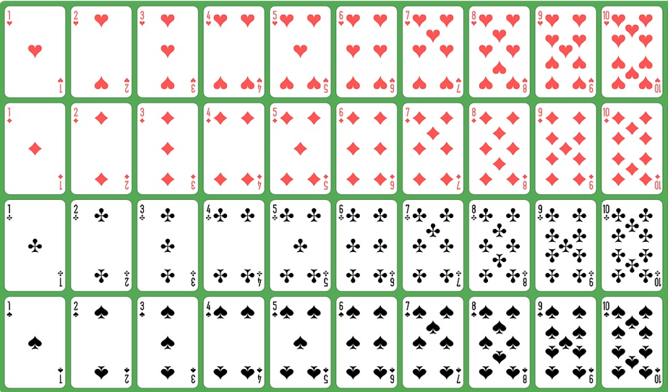

Number of Operations

Let's now see how many operations
these two methods have had to perform, approximately,
to sort the deck.

Method 1:

The first algorithm carefully examines the deck
comparing each card one by one
to extract the one with the lowest value.

If the deck has 50 cards, 49 comparisons will have been made.
After 49 comparisons, we have 1 card sorted,
and 49 unsorted.

To extract the second card with the lowest value,
we repeat the previous procedure
with the 49 cards that are still unsorted,
which will require another 48 comparisons.

And we repeat the same procedure over and over
until there are no cards left unsorted.

How many comparisons will have been necessary?

49 + (49 - 1) + (49 - 2) + (49 - 3) + (49 - 4) + ... + (49 - 48)

If we call the number of elements we want to sort 'N',
in this case N=50,
the number of operations needed will be approximately
N * (N-1)

Therefore, we can say that the cost of executing this algorithm is
"of the order of"
N squared.

Method 2:

We begin by reserving space for each card in a grid.
We extract a card from the deck
and place it in the space reserved for it in the grid.

We do the same with the second card
and with all the others.

How many operations are necessary to sort the deck?

One operation per card.

If the number of cards is N,
then the number of operations will be
of the order of
N.

Which is the best ?

Now that we have a measure of the number of operations
both algorithms need to achieve the goal
we can compare them.

The first one is of the order of N squared.
The second one is of the order of N.

The second algorithm accomplishes the task with fewer operations,
and therefore it's more efficient.

The Living System

Let's now return to the system we are analyzing,
the living machine.

Now that we've seen how two methods can be compared,
let's go back to the intelligent system composed by living beings
and examine the method it has used in terms of
algorithmic efficiency.

How efficient is it?
How many operations does it need to achieve the goal?
Are there algorithms that find the solution with fewer operations?
Could we suggest changes in the procedure to improve its efficiency?

To answer these questions, let's review the experiment.

Let's remember the problem

The board represents a maze, with an entrance and an exit.
We have placed the entrance at square 'A1', and the exit at square 'H8'.

On the board, we have only one token.
The token can move
only one square distance with each move,
and this is the only valid move.

The objective of the game is to move the token from the entrance to the exit.

And what we want to know is,
what is the path the token must take
to go from the entrance to the exit?

The distance between the entrance and the exit is
7 squares.

The token can only move one square at a time,
and therefore, it will not be possible to reach the exit with fewer than 7 moves.

It would reach the exit in seven moves,
in the case of finding the shortest path,
but it could be more,
depending on the method used to explore the board.

Going in circles, the number of moves could be infinite.

Let's now remember
how the solution to the problem was found:

We created an individual,
the first of its kind,
representing the initial state of the problem.

A board with a token placed at the entrance of the maze, position 'A1'.

All individuals of this kind will go through a life cycle
that consists of,
birth, reproduction, and death.

When we endowed this first individual with life,
it went through the stages of its life cycle.

It reproduced, generating all possible offspring,
and immediately after, it died, being removed from the system.

By completing its life cycle, it initiated a more complex process,
that goes beyond its own existence,
and that will continue even when it is no longer part of the system.

The process that it triggered with its existence
will outlive it.

And the following has happened:

First Generation

The offspring of A1 will occupy the positions marked with X.

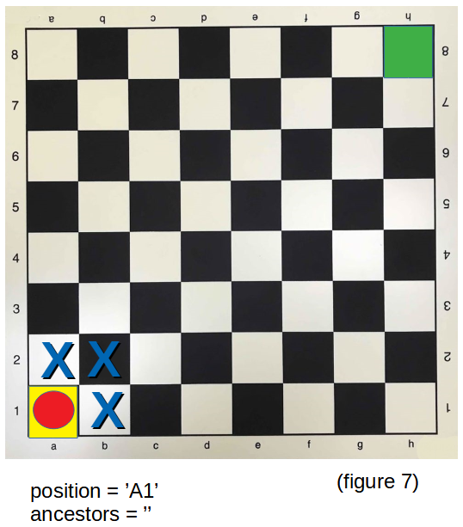

All of them will be born in the
first generation,
including B2.

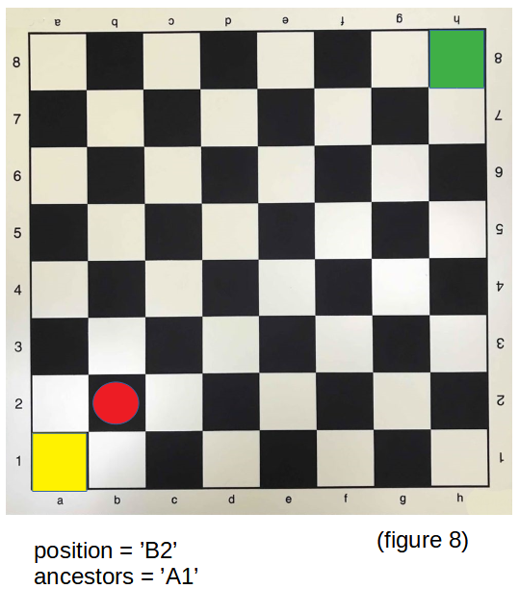

Second Generation

The offspring of B2 will occupy the positions marked with X.

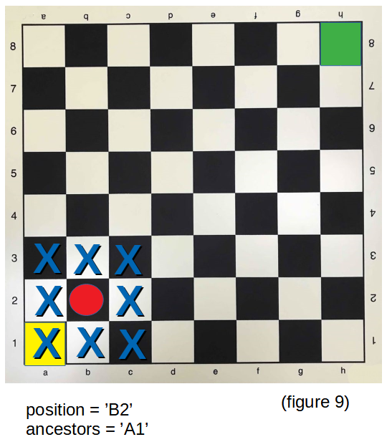

All of them will be born in the
second generation,
including C3.

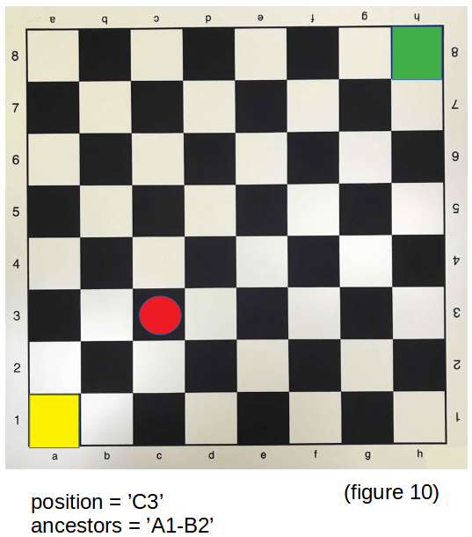

Third Generation

The offspring of C3 will occupy the positions marked with X.

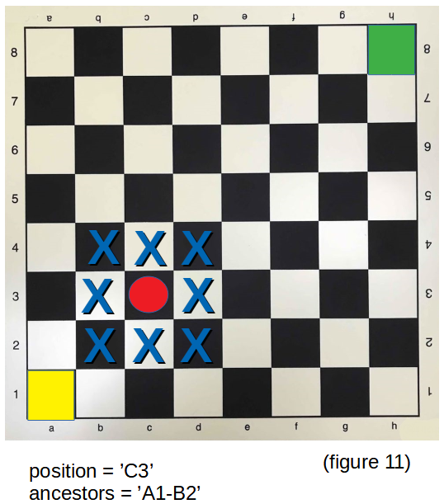

All of them will be born in the
third generation,
including D4.

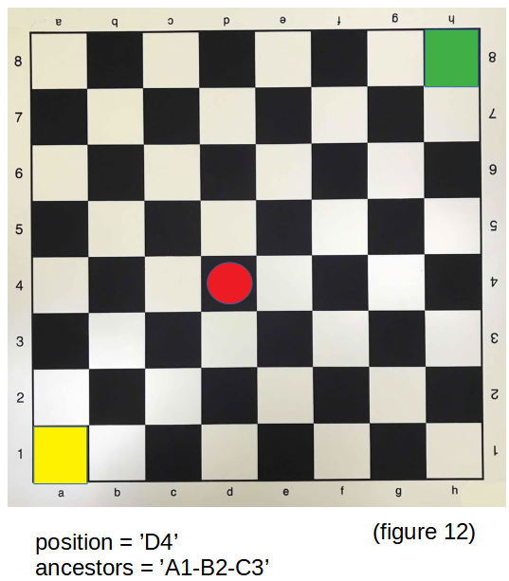

Fourth Generation

The offspring of D4 will occupy the positions marked with X.

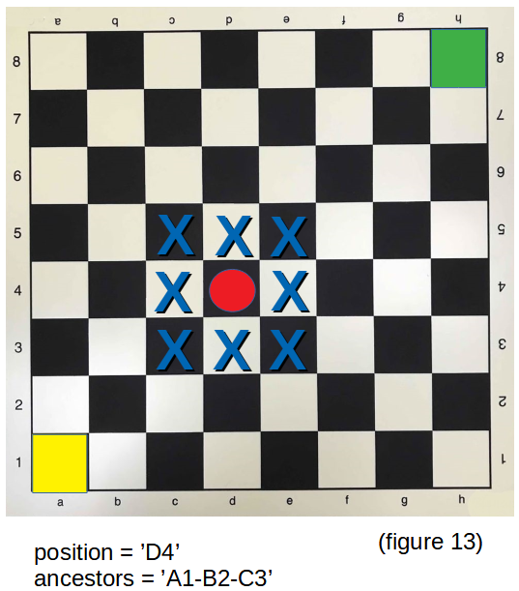

All of them will be born in the
fourth generation,
including E5.

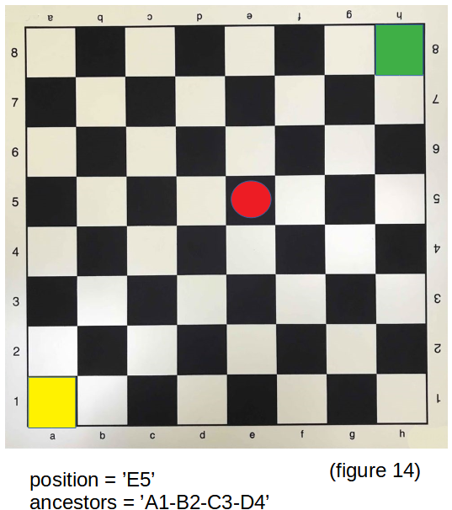

Fifth Generation

The offspring of E5 will occupy the positions marked with X.

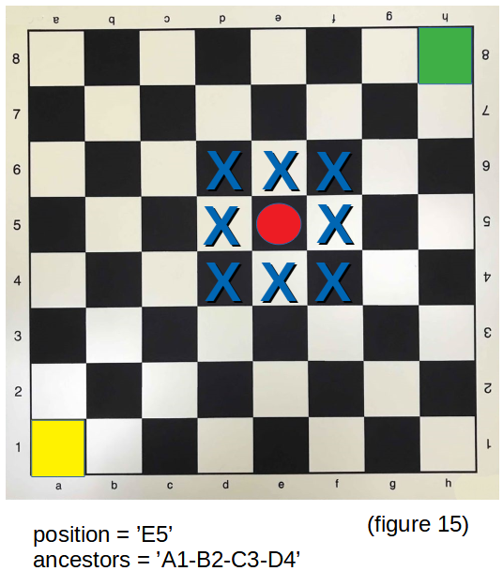

All of them will be born in the
fifth generation,
including F6.

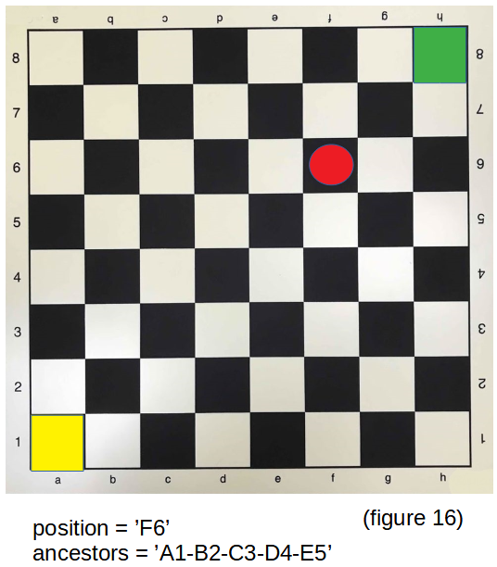

Sixth Generation

The offspring of F6 will occupy the positions marked with X.

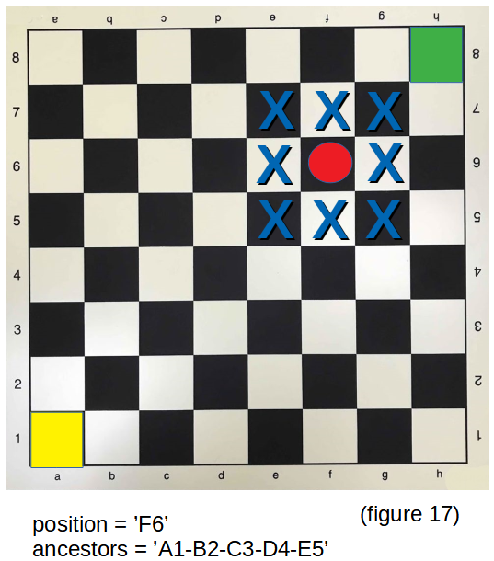

All of them will be born in the
sixth generation,
including G7.

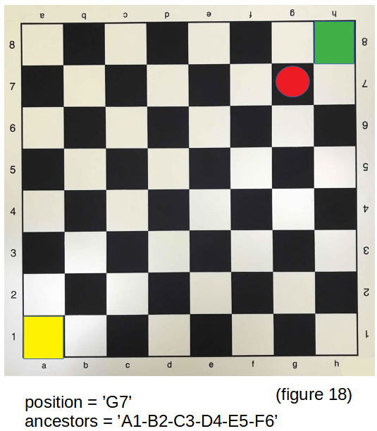

Seventh Generation

The offspring of G7 will occupy the positions marked with X.

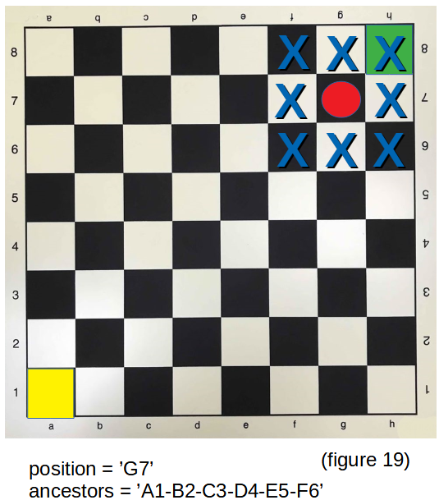

All of them will be born in the
seventh generation,
including H8.

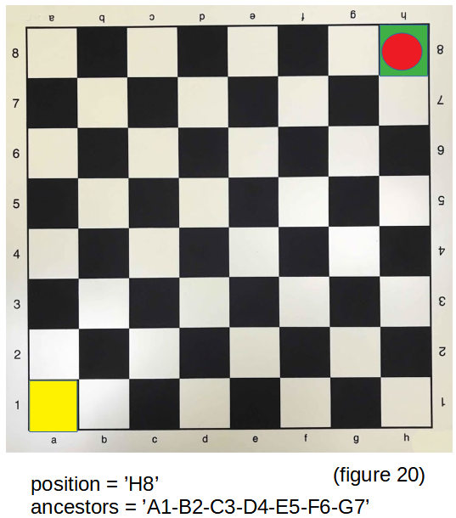

The process can stop at this point
because H8 is at the exit,
and it knows the answer to the problem.

Its list of ancestors describes the path that its family has taken.

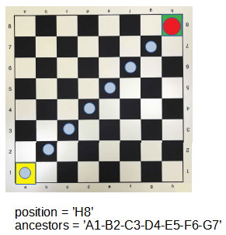

The system has found the answer after 7 generations.
The system progresses one step in the process with each generation.

And with each generation,
it moves one step in the right direction.

It doesn't get lost, it doesn't hesitate, it doesn't make mistakes.

It moves towards the goal
as if it knew where it was from the beginning.

With each step, it advances towards the goal,
along the shortest path.

We have established that at least 7 steps are necessary to reach the exit,
since it is at a distance of 7 squares
and the token cannot move more than 1 square with each move.

So,
the system has found the answer
with the minimum number of necessary operations.

We wondered
how we can improve the procedure that the system uses
to make it more efficient.

And that simply isn't possible.

It won't be possible to improve it.

There will never be a more efficient system than this,
because
the problem cannot be solved with fewer operations.

